Git Setup https://confluence.atlassian.

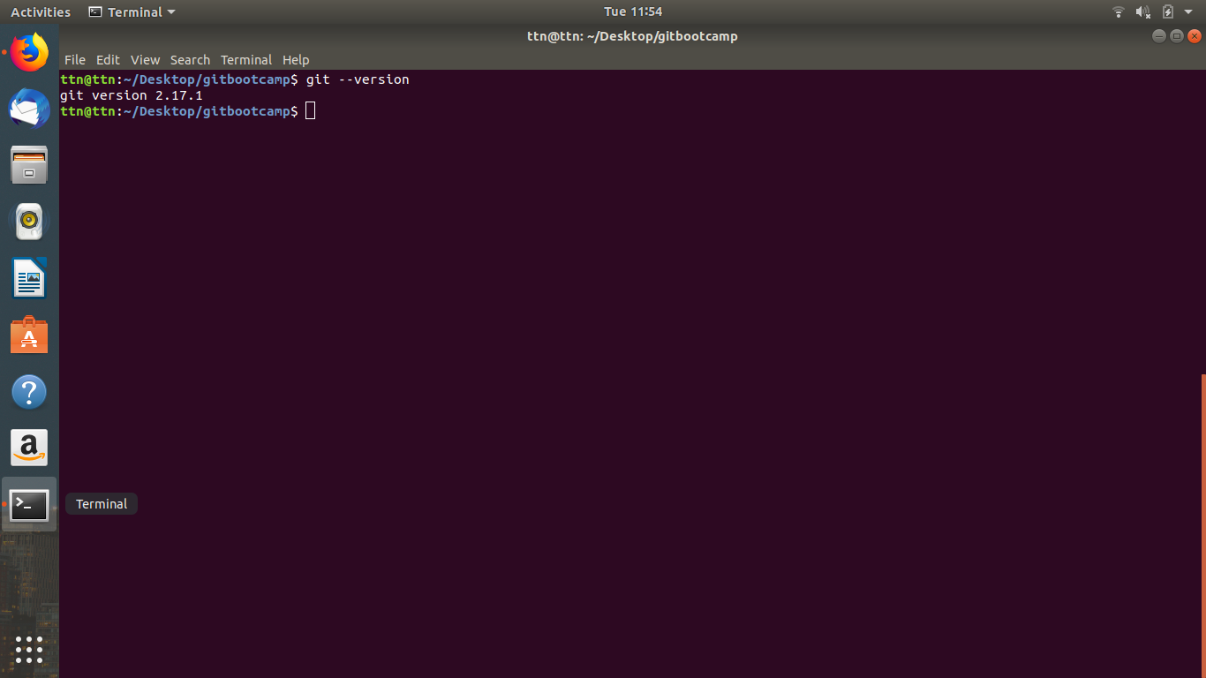

Initialize a Git Repository

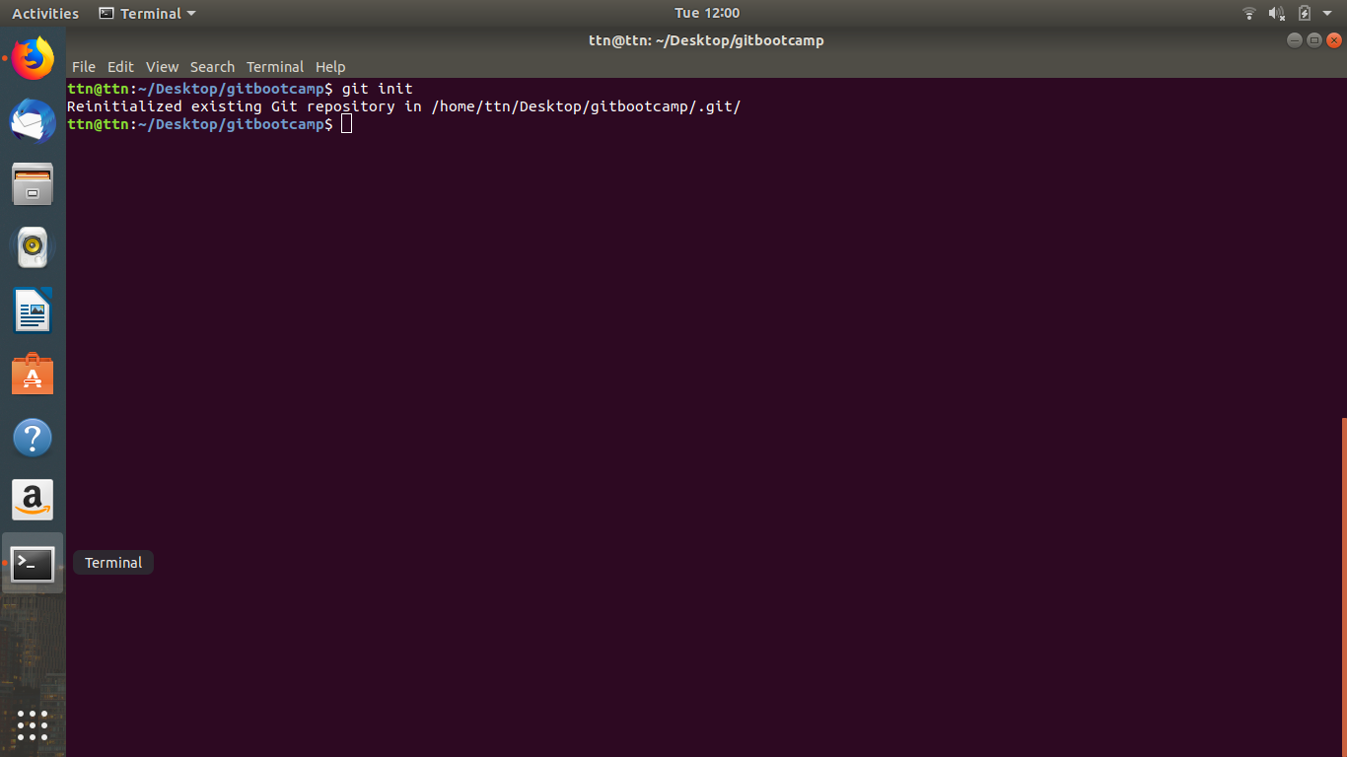
Unstage 1 file

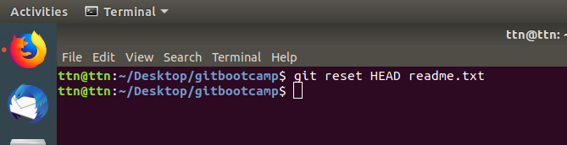

Add a remote
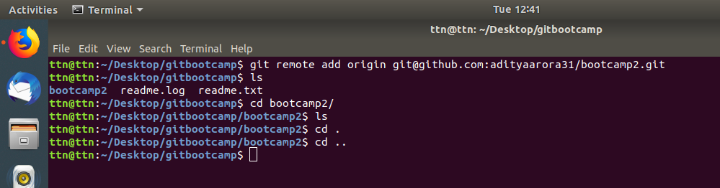
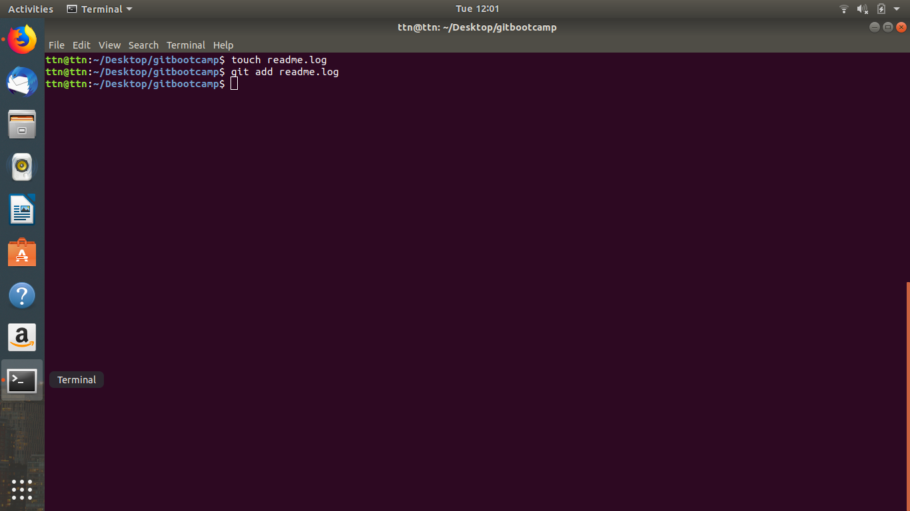

- Add files to the repository
- Push changes to Github

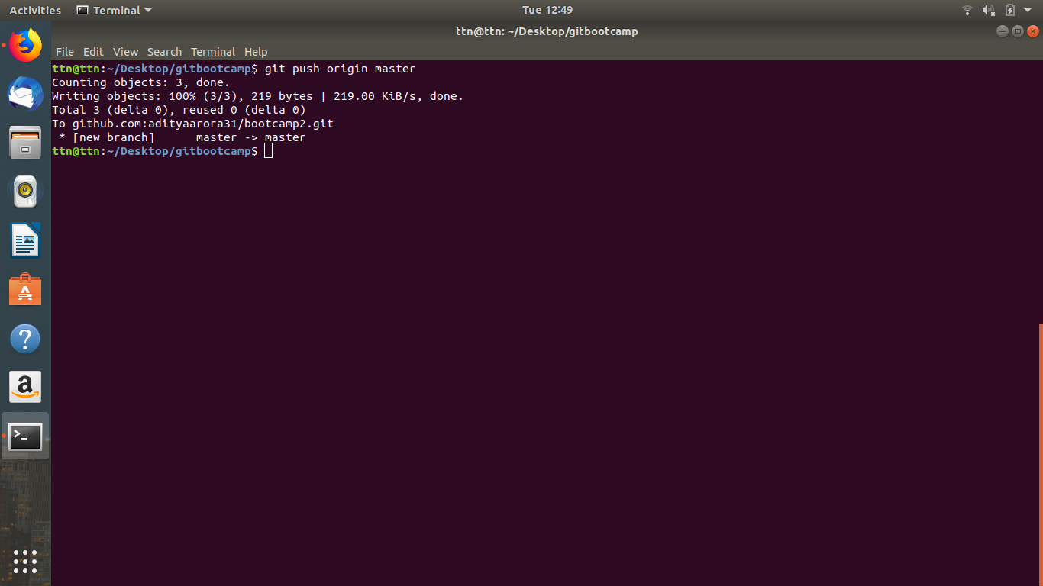

- Clone the repository
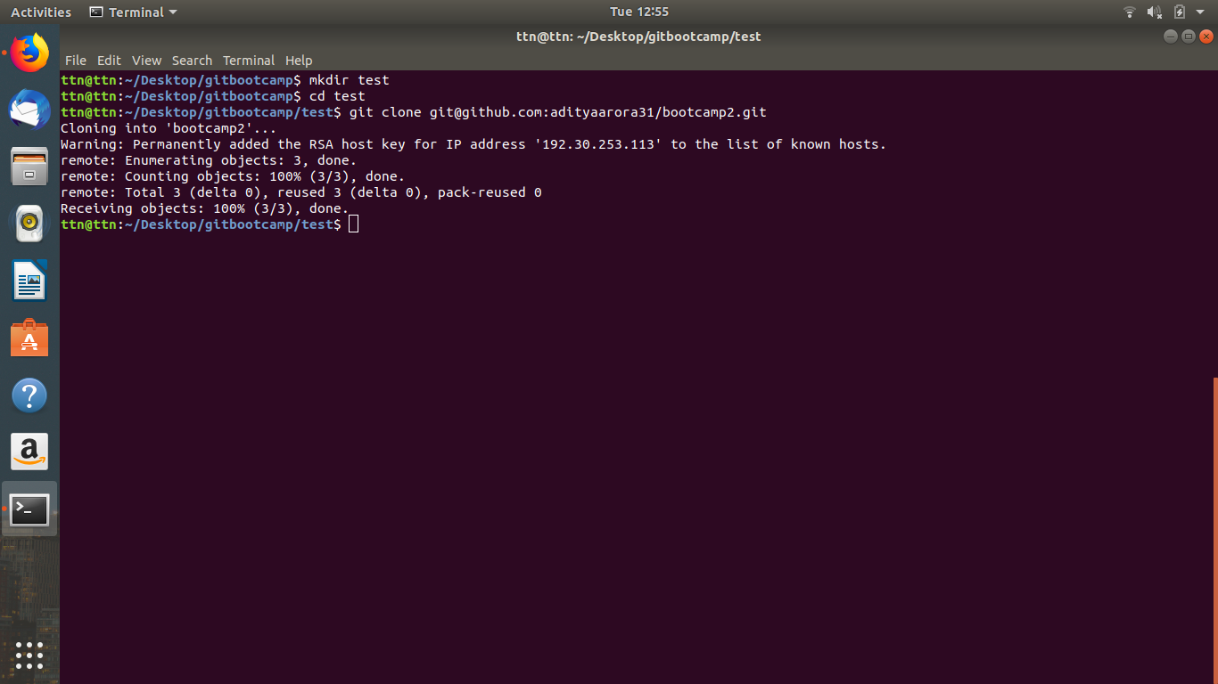
- Add changes to one of the copies and pull the changes in the other.

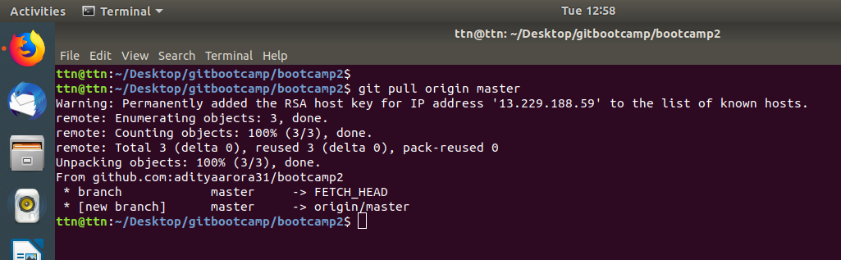
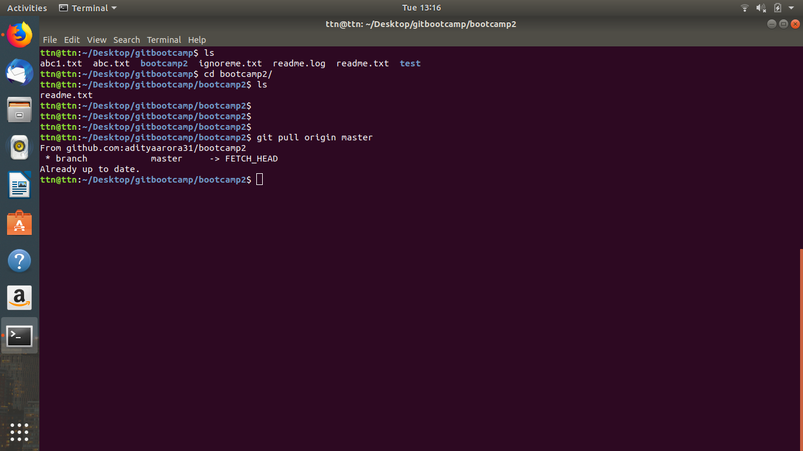

- Commit the file

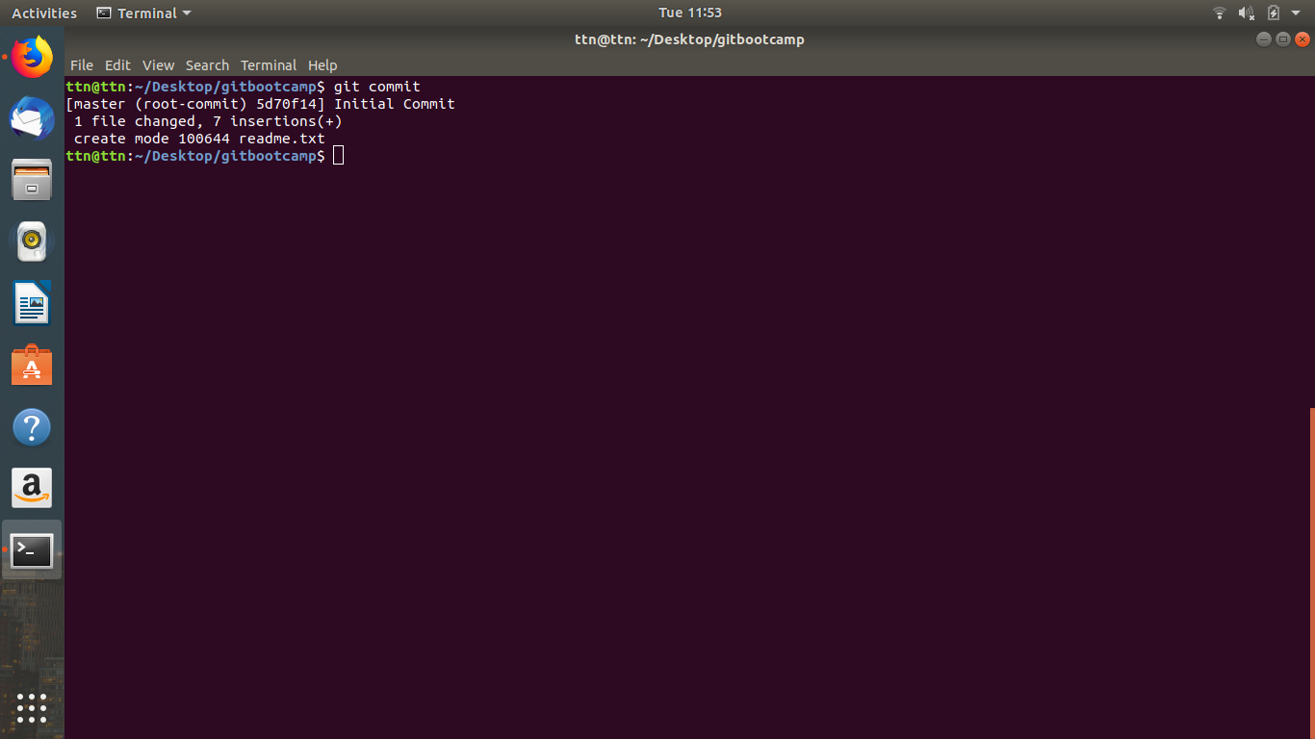

Add the following code to your .bashrc file : color_prompt="yes"
parse_git_branch() {
git branch 2> /dev/null | sed -e '/^[^*]/d' -e 's/* \(.*\)/(\1)/'
}
if [ "$color_prompt" = yes ]; then
PS1='\u@\h\[\033[00m\]:\[\033[
else
PS1='\u@\h:\W $(parse_git_branch)\$ '
fi
unset color_prompt force_color_prompt

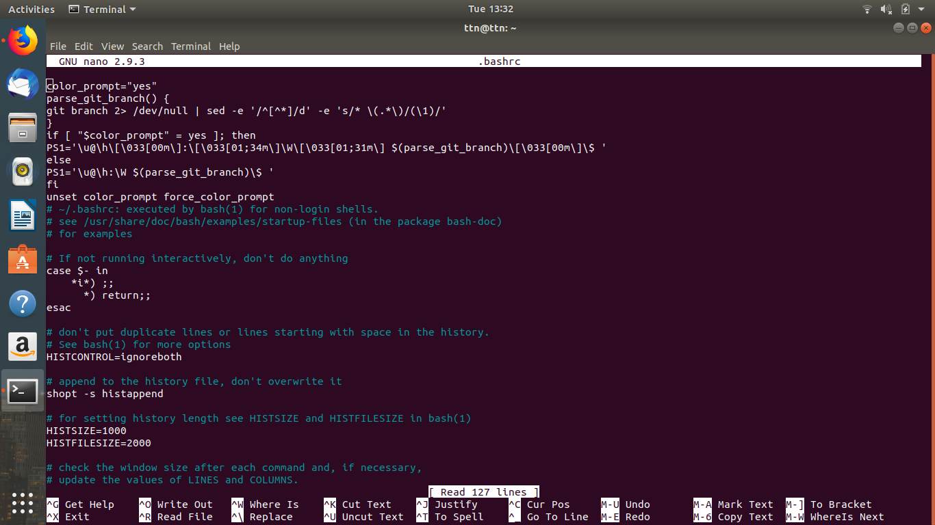

- Try merging and resolve merge conflicts

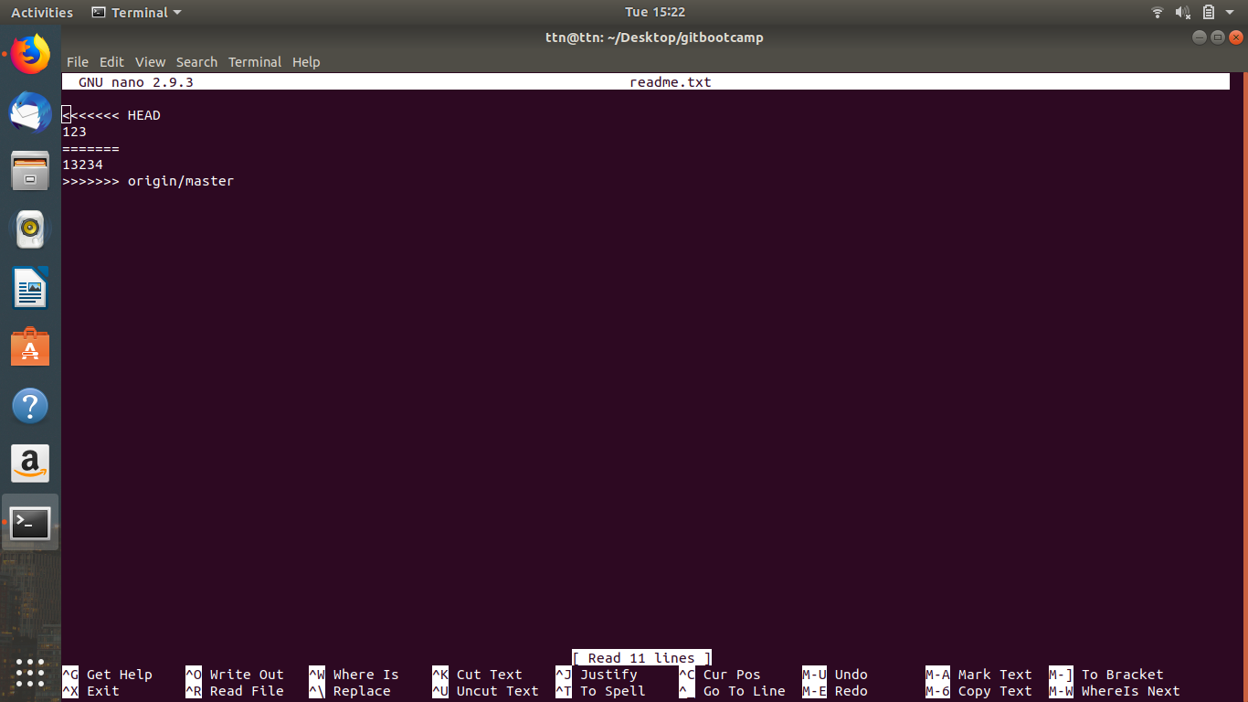

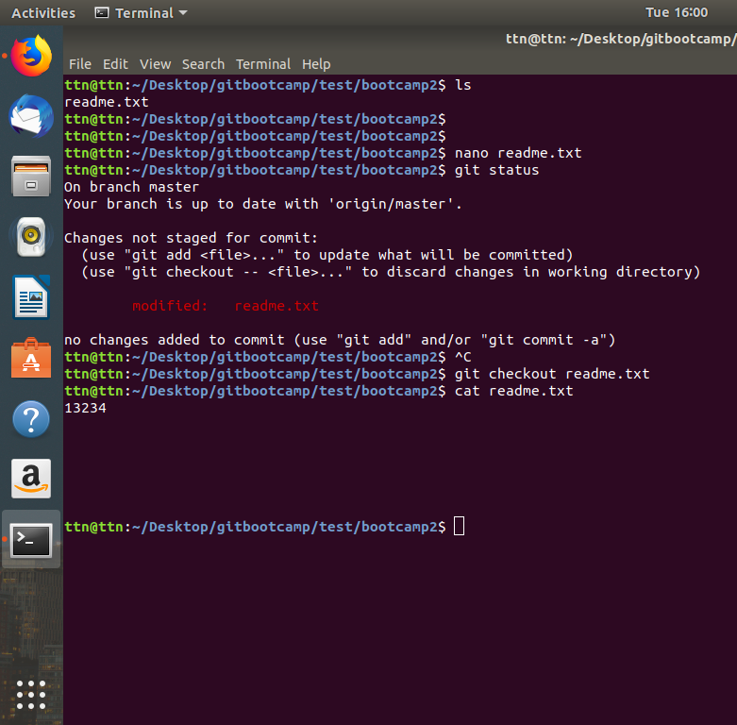

- Undo changes to a particular file

- Create a new branch.
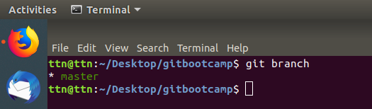

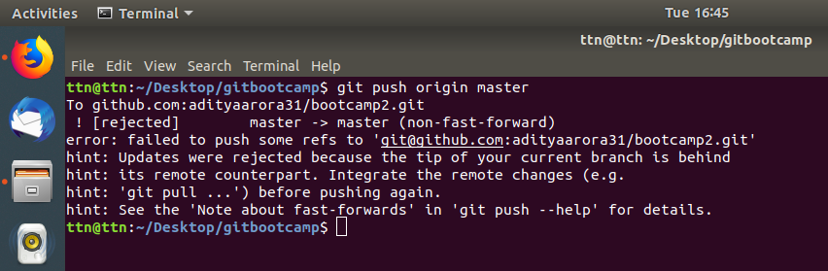
Diverge them with commits

Stash the changes and pop them
